
Tipping on DoorDash | Research Synthesis
Sep 9, 2022 | Vero Jimenez

How do Cx think about tipping Dx?
- Cx tip Dx to reward good service and/or support the worker with fair compensation. (Report: Why don’t Cx tip?)
- Cx who do not tip Dx do not because they are not able to afford the cost of tipping, or they do not have the desire to tip because of past delivery issues. (Report: Why don’t Cx tip?)

The amount that people tip is based on cultural norms, personal experience in the service industry, wanting to provide an incentive to handle order with care (specific to pre-tip mobile food delivery scenarios), expected extra effort (i.e. raining, apartment complex), and their understanding of "delivery fee". (Report: Cx Post Tipping)

Are Occasional Cx price sensitive to tipping?
- Tipping is not a top driver of churn among Occasional Cx. Cost concerns drive churn, secondary factors for churn are around quality, guilt and supporting local. As seen in previous UX research, functional price related barriers (delivery fees, inflation and service fees) are the top drivers of churn. This is followed by more emotional barriers of loyalty to a different app/subscription or guilt and frustration with quality that ultimately leads to churn. (Report: Churned Occasional Cx Research Report)
Overall Weighted Ranking | Item | % of Churned Occasional Cx Selected As Reason for Churn | Average Ranking (Out of 5)
1 | The delivery fees are too high | 53% | 2.3
2 | The prices of items are too high | 39% | 2.7
3 | The service fees are too high | 59% | 2.0
4 | I prefer/switched to using other delivery apps such as UberEats, GrubHub etc. | 30% | 2.5
5 | I feel guilty spending money on delivery | 25% | 2.5
6 | I was facing frequent issues with my deliveries | 20% | 2.1
7 | I started ordering from restaurants directly | 22% | 2.8
8 | I started cooking at home regularly | 21% | 2.8
9 | The restaurant/items I want to order are not on DoorDash | 19% | 2.7
10 | I started dining out more regularly | 9% | 2.4
11 | I am trying to eat healthier | 12% | 3.3
12 | DoorDash customer support did not meet my expectations | 9% | 2.3
13 | I don’t like having to tip | 12% | 3.4
14 | My DashPass got canceled | 4% | 2.7
15 | I found the DoorDash app hard/confusing to use | 3% | 2.8
Base: Total Churned Occasional Cx (n=233)

- Removing tip altogether is not a big lever for re-engaging Churned Occasional Cx. Financial levers that “stop the sticker shock” are of greatest interest to Churned Occasional Cx. The greatest opportunities are likely to exist from fixed flat fees, evergreen recurring $ off promotions, BOGO or caps on inflation. (Report: Churned Occasional Cx Research Report)
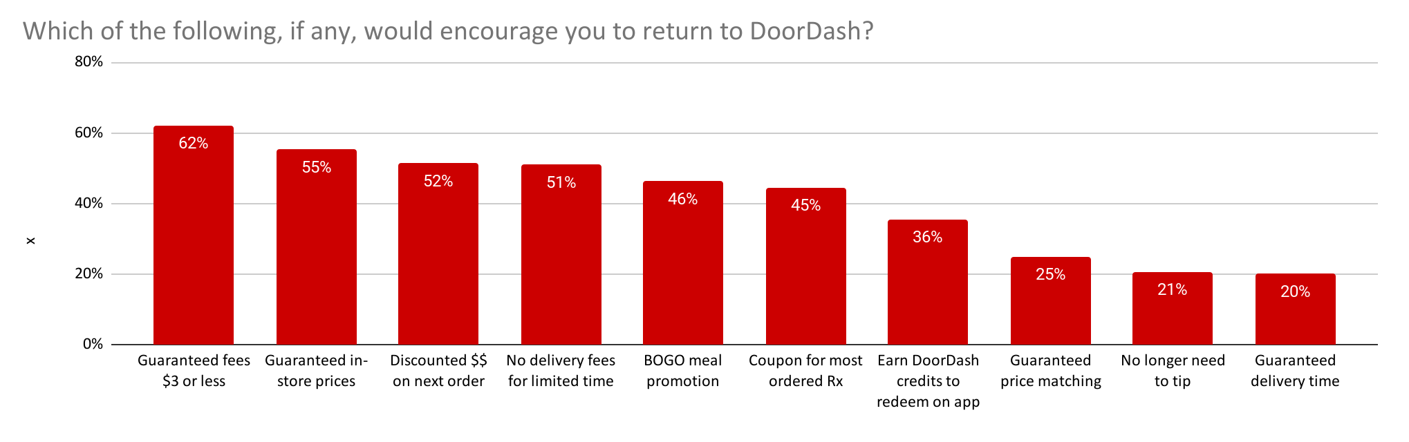Base: Total Churned Occasional Cx (n=233)

Why are Cx more price sensitive to fees than tips?
- Fees are a necessary evil: most Cx indicate that they have to pay a cost for convenience and understand that Dx and DoorDash need to get paid to continue to exist. However, they find the difference between delivery and service fees confusing and often have a hard time understanding how much goes to the Dx. (Report: NV Perceived Affordability & Value)
- Fees are the main contributor to sticker shock at checkout because consumers feel that they are inconsistent and therefore hard to predict and budget for. Consumers are confused about how fees are determined because they are inconsistent across restaurants/stores. E.g., nearby restaurants can charge a higher fee than more distant restaurants. Even DashPass subscribers struggle to articulate how much they save on fees and the mechanism that enables savings. (Report: Understanding frequent Cx visitor drop off).
- In contrast to fees, tips feel like a more predictable cost within a Cx’s control. Cx generally believe that delivery falls within the service industry and thus expect to be asked to tip. Although Cx don’t have a consistent tipping approach and amount, they at least feel like this is something within their control every time they order. Because it’s in their control, it contributes less to stricker shock than fees. (Report: Understanding frequent Cx visitor drop off).
What pain points with tipping do Cx have?
- Cx are unsure what % of fees/tips go to drivers. Being asked to tip in addition to paying multiple fees can feel too expensive and overwhelming for Cx who experience “sticker shock” at checkout. Cx do not have an issue with tipping in theory, as they are used to tipping at Rx, but when it is added to complicated fees it becomes bothersome. (Report: NV Perceived Affordability & Value)
- Cx struggle to determine whether & how much to tip because they haven’t linked DoorDash to their existing mental model for tipping. Compared to other service industry jobs (pizza delivery, waiter, hairdresser), Cx were the least likely to tip Dashers. This is because Cx think that Dashing is easy (compared to waiter and Hairdresser, 51% of Cx think that dashing is easier than being a waiter). For most Cx, the service of delivery is straightforward. They rarely could think of experiences where drivers rarely exceed expectations and would "earn" an "extra" tip based on their service. (Report: 2021 Dx Earnings / Tipping / Cx POV)
Opportunities
- Shift customer mindset from "hoping" drivers get tipped to "knowing" drivers get their tip by (Report: Cx Post Tipping)
- Dx think dashing should be tipped as high as waiters; Cx can’t imagine what would make them provide “exceptional” service. Demystify the work that Dx do to complete an order so that Cx can easily link DoorDash to their existing mental model for tipping (e.g., 15% tip to waiter at Rx). (Report: 2021 Dx Earnings / Tipping / Cx POV)
- Personalize tipping recommendations based on Cx’s previous behaviors (e.g., recommend the same tip for carts of similar value) (Report: Understanding frequent Cx visitor drop off
- Consider saving tipping preferences for Cx so it’s one less thing to think about at checkout (e.g., default to 15%) (Report: Understanding frequent Cx visitor drop off

